Spring 2021 - Big Data Analytics Demissie

# Apply for AWS Student Account

**Sign up for AWS Educate**

1. Open [https://aws.amazon.com/education/awseducate/.](https://aws.amazon.com/education/awseducate/)

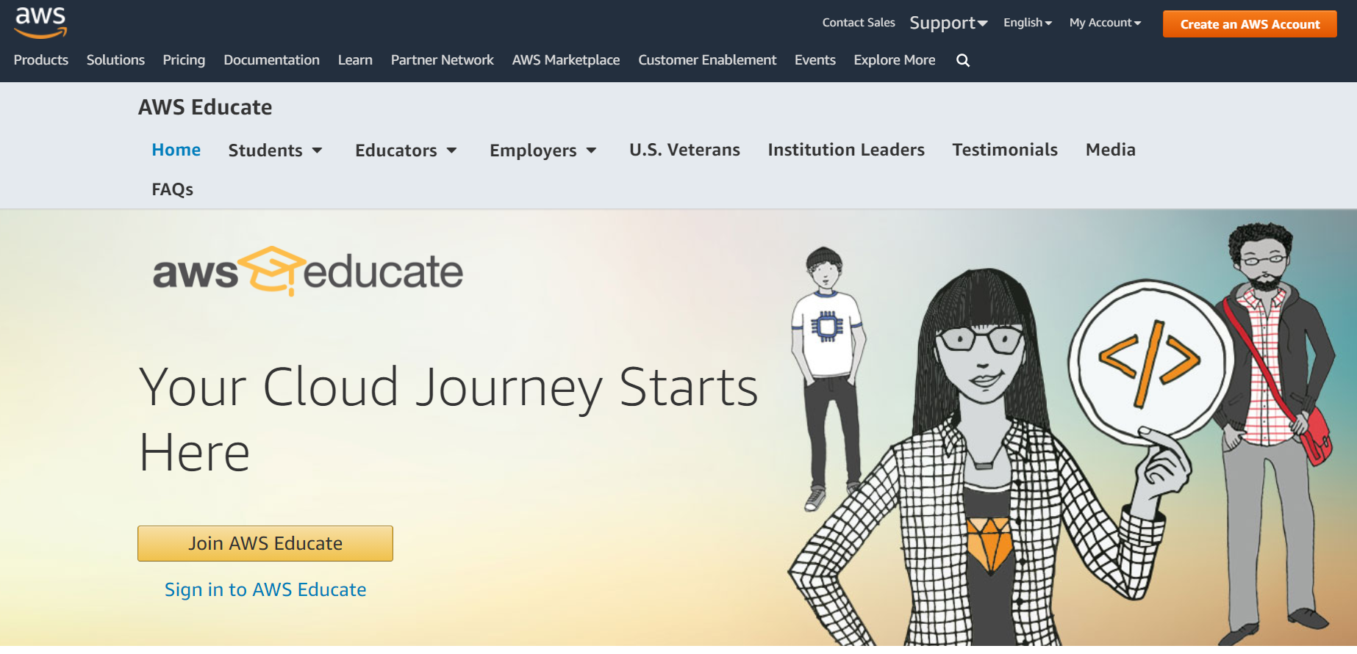

1. Click on **Join AWS Educate** >> **Student**, and register with your Fordham information.

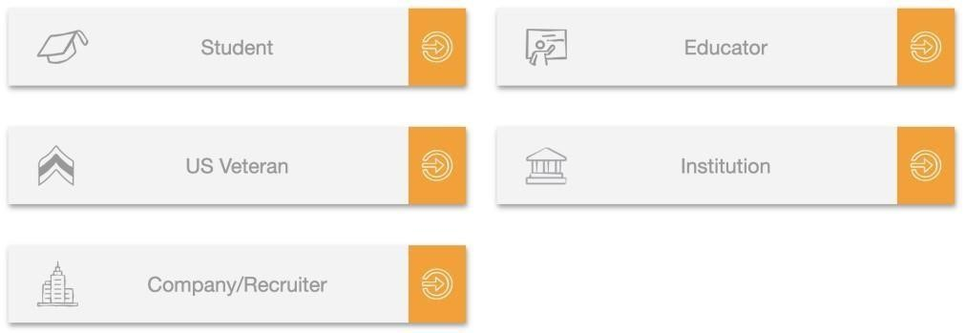

1. Follow the online instructions to verify your email and wait for the approval.

***Note****: The approval may take one day, and after one day, you will receive an email titled*

*‘AWS Educate Application Approved’.*

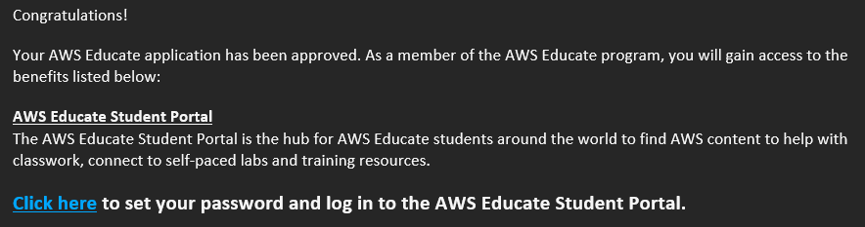

1. After receiving the AWS Educate Application approved email, click on the link provided to set a password, and log in to your account.
2. After logging in, you will see this:

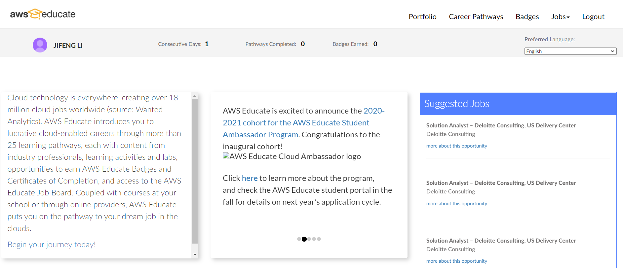

You have finished the registration process!